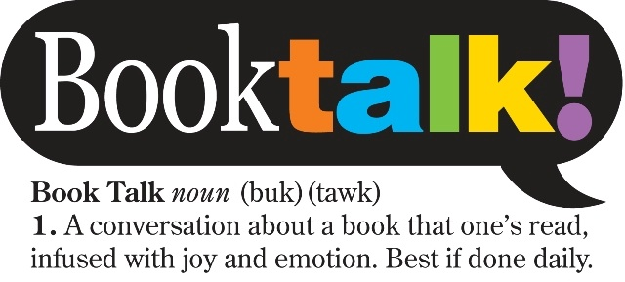
Questions & Strategies to Ask Your Reader!!
Book discussion is one of the best ways to support your child's literacy. The analytical skills used in discussion are what your child needs to succeed in school—and life. But because you're probably not reading all the books, it's sometimes hard to have a discussion about them.
Tips on how to start and sustain a book discussion with your child: avoid dead-end, yes/no questions such as "Did you like it?"
Before your child reads a book, ask:
- Why did you select this book? If it is a series, ask if he/she has read others in the series.
- What makes you think this book is going to be interesting?
- What do you think the book is going to be about?
- Does this book remind you of anything you've already read or seen?
- What kind of characters do you think will be in the book?
- What do you think is going to happen?
While your child is reading a book, try asking:
- Will you catch me up on the story? What's happened so far?
- What do you think will happen next?
- If you were that character, what would you have done differently in that situation?
- If the book was a TV show, which actors would you cast in it?
- Where is the book set? (time, place- future, past, school or maybe an exotic location)
- If the main character in that story lived next door, would you guys be friends?
- What does the place look like in your head as you read? Would you want to visit there?
- Did you learn any new words or facts so far?
After your child has finished a book, ask questions like:
- What was your favorite part of the book? Why?
- Who was your favorite character? Why?
- What was the most interesting thing you learned from the book?
- Why do you think the author wrote this book?
- Would you have ended the book differently? Did it end the way you thought it would?
- Did the problem of the book's plot get solved?
- If you could change one thing in the book, what would you change?
Here are some ways to help your child build vocabulary as he or she reads:
- Ask your child to place a sticky note on each page of a book that has unfamiliar words. One can also just write the unfamiliar words, and the page numbers they occur upon, in a notebook. You can use context clues or look them up in a dictionary later, and refer back to the book.
- Play a description game with your child. Look at a place or object and say a single word that describes or relates to it. Then your child has to say a different word that describes it, and you take turns until one of you can't think of a word. If you're looking at a tree, you might say "green," and your child might say "tall." Pretty soon, though, you will run out of easy words and have to say "evergreen" and "photosynthesis." This gets both of you to use words that you don't normally use.
The students who are the most successful readers /learners see that modeled at home. Your child should read for at least 20 minutes each day to continue growing.
You can help make this happen! Here's how:
- "If I want to read it, I will read it:" use Find a Book to discover interesting, targeted books together.
- Practice reading hygiene: turn off TVs, radios, iPods and computers.
- Or, read during the ads: mute the TV when advertisements come on and sprint-read until the show resumes.
- Don't wait to read until after tuck-in: children need to see their parents reading.
- All for one: make time for the whole family to sit down together to read, schedule a regular family library night, or have everyone in the house read the same book.
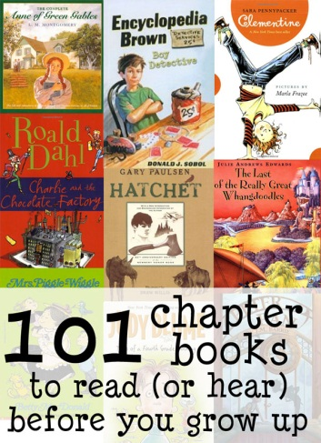
- Read aloud to each other.

Work reading into daily life
. Here are a few ways to connect children with relevant reading experiences:
- Would you read that recipe to me while I cook, please?
- Look, here's a review in the newspaper of that movie you've been wanting to see.
- I don't agree with you about that issue. Find an article online to convince me.
Here are some websites with resources & E-texts:
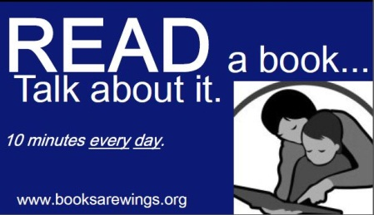
https://www.lexile.com/using-lexile/lexile-at-home/how-to-discuss-a-book-with-your-child/
http://www.pragmaticmom.com/2011/02/must-read-books-should-have-won-a-newbury-award/
http://www.feelslikehomeblog.com/2013/04/101-chapter-books-to-read-before-you-grow-up/
http://www.mycapstonelibrary.com/login/index.htmlUsername: diglearning Password: go4it
http://www.pebblego.com/content/choose_product.php Username: bennington Password: read

Adapted from www.lexile.com and other sites. Compiled by R.Santoiemma Jan 2014

